****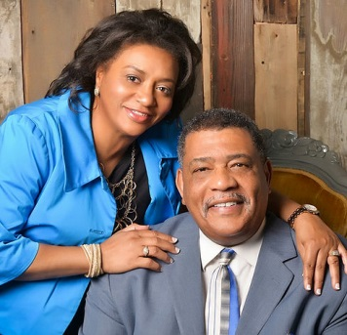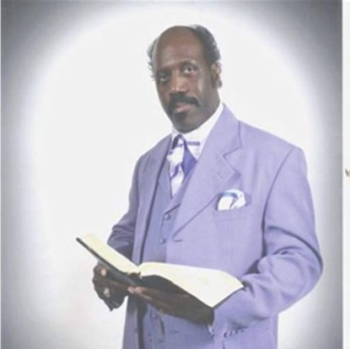

**Conference**

**Word of Life Christian Outreach Center**

Physical address: 8930 Silk Hope/Liberty Rd. Siler City, N. C. 27344

**AUGUST 25th @ 7:00PM, 26th @ 9:00AM 2017**

**Word of Life Christian Outreach Center**

Physical address: 8930 Silk Hope/Liberty Rd. Siler City, N. C. 27344

Mailing address: PO Box 1068 Liberty N. C. 27298

Website [www.wordoflifeschoolofministry.org](http://www.wordoflifeschoolofministry.org)

Email: info@wordoflifeschoolofministry.org

Carl E. Thompson Senior Pastor: (919)8372407;

Church Phone: ([336)-622-6259](tel:(336)%20622-6259)

WORD OF LIFE SCHOOL OF MINISTRY

**Host Pastors:**

**Carl E. Thompson, Sr. Senior Pastor; Mechelle Thompson, Co-Pastor**

**Guest Speaker:**

**Apostle S.E. McKinney of**

**The Greater Oasis Temple**

**Pentecostal Deliverance Church**

**229 E, Nash St., Wilson N.C**

Coming Soon!!

**Word of Life School of Ministry**